

Concordia Institute for Information System Engineering (CIISE)

Concordia University

**INSE 6300 Quality Assurance in Supply Chain Management**

Project Report on

**Reducing Waste and Improving the Supply Chain Model of Tim Hortons**

Submitted To:

**Dr. ARASH MOHAMMADI**

Submitted By:

|  |  |
| --- | --- |
| STUDENT NAME | STUDENT ID |
| Jatin Sehgal | 40076837 |
| Natasha Basutkar | 40081017 |
| Sushma Reddy Gurram | 40086757 |
| Uday Amrinder Singh | 40071019 |

**Reducing Waste and Improving the Supply Chain Model of Tim Hortons**

***Abstract: The Tim Hortons’ Supply Chain model is analyzed to understand the problems that have been caused due to improper demand forecasting leading to wastage of Home treats as reported in various stores in and around Quebec. The required financial metrics have been analyzed and applied to the model. Similarly, the different forecasting techniques have been applied to identify the best suitable one for the Tim Hortons supply chain model.***

***Index terms: Equity, Assets, Trend, Level, Seasonality, Liability, Home treats, Holt’s, Trend-corrected, Winter’s, Inventory, Replenishment, etc.***

I. INTRODUCTION

Our project is based on analyzing the Supply Chain Management for Canada’ #1 Coffee selling brand, the Tim Hortons. This popular fast food restaurant chain has made its mark in several parts of Canada operating in more than 4304 locations as per studies during the year 2013. It is also making plans to expand its market in US and establish new markets in the other parts of the world. The major areas for running the Supply Chain for Tim Hortons are Procurement & Logistics, Manufacturing and Warehouse & Distribution. Tim Horton’s existing supply chain network is based on connecting various suppliers ranging from Dairy Farmers, Raw material suppliers, Dairy Cattle, Palm Oil, etc. These products are sourced from key responsible supply chain practices as regulated by the Compliance Act – Business Partner & Supplier Code of Conduct (BPSCC).

As we all know, Tim Hortons coffee is the most selling product, however there are other products as well such as Breakfast, Baked treats, Lunch combo, etc. It has been reported that approx. 4.0 Billion$ of revenue is generated through Baked treats in Canada alone while close to 1.0 Billion $ of sales is reported in US. By this, we know that Baked treats such as Bagels, Muffins, Croissants, Doughnuts are very popular among the customers. However, Tim Hortons major objective is to offer products that are ‘Always Fresh’ for the customers which means that the baked products will be wasted soon after they expire which is limited to upto 8 hours.

The below chart lists the quantity of major products baked in the Home Treats category and the remaining quantity that is wasted due to improper demand forecasts. The numbers illustrated below are analyzed daily for a period of 8 hours. As we observe, close to 20 – 30% of products baked are wasted everyday due to inaccurate planning of demand. This wastage can negatively affect the margins in an individual store and the business on the whole.

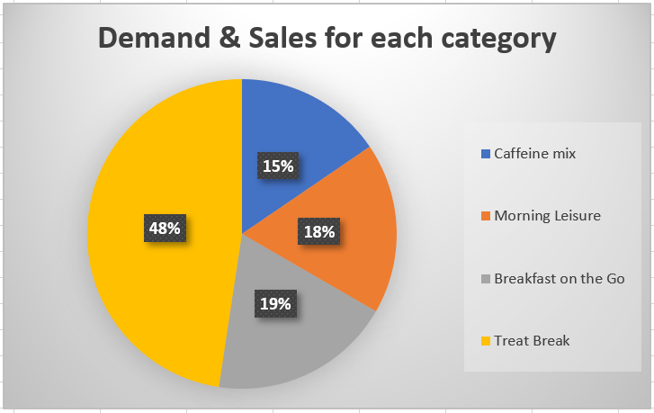

To minimize the wastage, the following sections detail the necessary metrics to optimize the supply chain strategies for Tim Hortons and have also developed a forecasting model to de-seasonalize demand and predict the future sales of these products. Following these steps, the model also analyses the error in the forecasted data and proposes alternative solutions to minimize these errors.

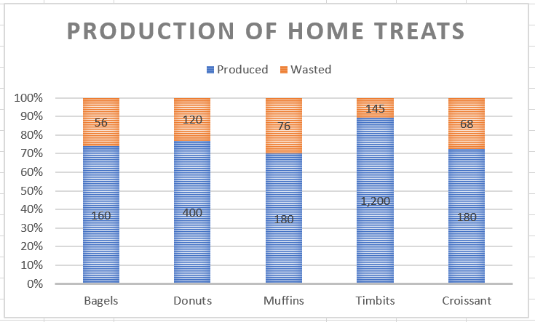

II.TIM HORTONS COMPETITIVE STRATEGY

Tim Hortons’ products have price lower than competitor’s goods. The company uses low cost as a source of competitive advantage. Tim Hortons also does not wish to sacrifice quality, providing the finest Arabica coffee and striving for high quality customer service. Tim Hortons has strong competition Starbucks. One of Tim Hortons biggest competitive advantages is price

1. *Comparison with Starbucks:*

Compared to Starbucks of the same size, Tim Hortons is much more affordable. Starbucks drink price is different by location, but they are generally higher than Tim Hortons prices. Another competitive advantage of Tim Horton is their simple menu. Some people get confused when trying to order at Starbucks they are not able to pick the type of how many shots of espresso, what kind of milk, and sizes that aren’t the typical small, medium and large but tall, grande and venti.

III. TIM HORTONS SUPPLY CHAIN MODEL

Tim Hortons supply chain is made up of a wide network of suppliers, some of whom provides goods that ultimately end up in their restaurants, while others provide with goods or services that help them in day-to-day business operations. Tim Hortons work closely with many suppliers that provide the raw ingredients used to make their products, such as wheat, oil and sugar.

They manage their supply chain by working closely with the suppliers. For example, every two years, they host a Supplier Symposium where best practices are shared amongst their supplier base. In 2014, for the third year, they evaluated food, beverage, packaging and equipment suppliers, which included their sustainability practices, goals, and innovation. The figure below illustrates six key levels in the coffee and other products supply chain that are very important to better understand the verification process: Farmers, Manufacturing companies, Distribution centers, Intermediary, Exporter, Importer, and Roaster/Baker, Consumer.

*A. Farmers and producers*

They can range from individual “small holders” (that can hold less than five hectares of land) to large private estates (50 hectares or more). Farmers can organize themselves into formal organizations, associations or cooperatives.

*B. Manufacturing and Distribution Centers*

There are few products which needs to be manufactured from the stock received from farmers. It takes place here and sent to the other centers.

*C. Intermediary*

It is a trader or “middleman” operating at origin that provides farmers services and assistance in getting their stock to market. Intermediaries range from professional organizations to independent traders.

*D. Exporters*

These are organizations operating at origin that process and commercialize coffee and other products from farm gate level to meet the needs/specification of international buyers.

*E. Importers*

These are global merchants who bring goods and commodities from the origin country to the place of sale and exchange. For example: Coffee is imported prior to roasting – as “green coffee.”

*F. Roasting and Baking process*

This tends to take place close to where the products such as coffee, bagels, etc., will be consumed. This reduces the time that roasted coffee spends in distribution, the time it takes to prepare the bread helping to maximize its shelf life.



Before the product is received to the importers, inspection and verification process will be done to check the quality and quantity of product.

**IV. METRICS INTRODUCTION**

Supply Chain Metrics may include measurements for procurement, production, transportation, inventory, warehousing, material handling, packaging and customer service. There are hundreds of metrics that can be used to score Supply Chain Management performance. The following are some of the most common.

By collecting and analyzing key supply chain metrics you will be able to spot inefficiencies within your company while encouraging on your current strengths and establish goals that will help your supply chain scale with the success of your company.

Metrics are a way to measure performance. It is important that they present a strategic and tactical understanding about the organization. The challenge of a supply chain is the length, scope, number of internal and external stakeholders and overall complexity. No other activity has all this—suppliers and factories around the world and global customers KPIs (key performance indicators) must be measurable. Some of these are good. However, they do not present a view of the total supply chain.

Financial performance metrics are important because they get the economic consequences of business decisions.

Following are some financial metrics:

1. *Return on equity*: Net Income/ Average shareholder equity

Equity = difference between value of assets and value of liabilities of something owned

Total current assets of Tim Horton’s are valued at= $ 506,892

Liabilities and equity = 453,750$

Equity= 506,892 $-453,750 $=53,142

Net Income= 114, 955 $

Return on Equity= 114, 955/ 53,142 =2.163

Tim Horton’s is recording is recording a positive net income so return on equity is also positive.

Note: Negative return on equity always doesn’t mean that there is something bad for the company as profitability is also measured in terms of free cash flow too.

1. *Return on assets***:** Earnings before interest/Average total Assets

*c) Earnings before interest:* Total profit including all income and expenses minus interest expenses.

Assets= economic value of the company.

Total cost and expenses= 656,525 $

Income before income taxes= 160,341 $

Earnings before interest= 8, 16,866 $

Assets=2,265,752 $

Return on Assets=0.360

*d) Asset turnover ratio:* Total sales in the fiscal year / (beginning Assets + Ending Assets) / 2

Total sales = 575,780 $

*e) Profit margin:* Percentage of sales that turned into profits. (Net income/Net sales)

Sales= 575,780 $

Revenues= 825,353$

Net income= Total revenue – Expenses

Profit margin=114955/575,780=0.199 or 20% approximately.

Note: 20 % profit margin is ideally very good for a food sector company which has large number of overheads in terms of inventory and raw materials.

*f) Accounts payable:* Total supply purchases/ (Beginning accounts payable + Ending Accounts payable)/2 = 180,102 $

Accounts payable is positive because company at this point owes more to its vendors than it did the same time last year.

*g) Cash to Cash cycle:* 44,877$

*h) Property, plant and equipment:* 1, 615, 880 $

**V. CUSTOMER SEGMENTATION**

Customer segmentation as the name suggests is dividing the customer base into segments. As we know customers are the most important part of the supply chain as they are the ones that induct cash into supply chain. A careful study of consumer interests and behaviors while buying the materials and products, divides them into segments with similar interests and is called as customer segmentation.

In general segmentation can be divided into four broad categories. These are **geographic, demographic, behavioral, and psychological**. By geographic, we mean grouping of people that are similar in terms of their country, city, density, population, language, climate and area. By demographic, we tend to imply those social groups that are similar in terms of their age, gender, social status, family income, life stage, occupation etc. By behavioral, we means a customer who wants the full value for their money or the one who is a high value customer in terms of purchasing capacity. Some special occasions, days and festivities also influence the behavior of the customer. The fourth category psychological is a complex one and a deep understanding of the subject of psychology is required to study this customer base.

Tim Horton’s work under the **75 seconds rule**. Every Tim Horton’s server must serve the customer’s needs be it in the form of coffee, donuts, sandwiches or drinks in under 75 seconds. Thus, the target of Tim Horton’s is the customer base that desires to fulfill its hunger pangs in a nick of a time. He /She may be a college going student, university lad, a construction worker who stops by for his dosage of caffeine, an office going daily commuter, a commuter who travels by car and has stopped by to fill the gas. Tim Horton’s is a new generation restaurant built to target set of customers who avoid cooking at home and would instead like to grab a meal and coffee from outside on their way to work or university. It targets a customer base who avoids eating every now and then at fancy restaurants and hence eat economically. Such type of customers wants every value for their money and range from those with low to moderate purchasing power. On special occasions, people may throng to buy a pack or a dozen of donuts, but it loses a major chunk of its sale that day because its holiday for office goers.

In terms of demography, it has been found that Tim Horton’s is the favorite of those with low or middle level incomes. The consumption of Tim Horton’s food decreases with the age and ultra-rich people generally pay a visit to star bucks and other exotic coffee chains. Tim Horton’s also lures young, urban diners with its various reward schemes like loyalty points with which after every 7 purchases of coffee, baked good, tea customer gets eighth one for free. This is aimed to promote customer loyalty. Every year there are mega reward schemes like Tim Horton’s roll up the rim in which some selected customers get many big rewards.

Tim Horton’s has transcended all kind of language, climate and ethnic barriers. It has more than 4000 stores throughout the length and breadth of the country. It’s one of the favorite roadsides eating joints. Tim Horton’s is often cold shoulder to the needs of that segment of population that would like to meet their friends over a cup of coffee and the ones that would sit and relax with a book for a while in the serenity of a place while sipping their coffee.

**VI. DEMAND & SUPPLY UNCERTAINITY at TIM HORTON'S**

Demand uncertainty and implied demand uncertainty are spoken in two different contexts. Implied demand uncertainty is an uncertainty that arises because of the customer needs for the product i.e. customer places an order and supply chain fail to fulfill it. Often, it’s the case when demand exceeds supply. Demand uncertainty is an uncertainty in the customer demand. Supply uncertainty is some adverse event that occurs in the supply chain that breaks the balance of entire supply chain and some remedial measures needs to be taken to re-establish the balance in the supply chain.

Certain aspects of business at Tim Horton’s are outsourced to third parties for cost cutting and to bring in more efficiency. If third party fails to deliver its services on time, it may lead to incurring of additional costs to this brand and is a classic case of supply uncertainty.

When we combine different scenarios, we can create spectrum of demand and supply uncertainties.

1. Tim Horton’s introduced plant-based products like beyond meat and beyond burger as a special offer for the limited time in the country. When beyond meat was introduced, it was primarily targeted for the vegan and vegetarian customers other than bagels and coffee. Therefore, this product had **high implied demand uncertainty and high supply uncertainty**. Although Tim Horton’s made sure that from its end there is no supply uncertainty for beyond meat products, but they were met with lukewarm responses in all other provinces except British Columbia and Ontario. There is an implied demand uncertainty and company doesn’t want to take further risks on that, so it takes off beyond meat products from its menu.
2. Tim Horton’s gets its supply of raw materials like wheat, oil and sugar from third parties whose prices regularly fluctuate. Tim Horton’s insures itself against these fluctuations using future contracts. Tim Horton’s coffee is made from Arabica beans. Climate changes like global warming can play a havoc and disturb the delicate balance that Tim Horton’s has maintained in the prices of its coffee. Many agricultural products, such as coffee, are examples of supply chains facing low levels of implied demand uncertainty, but significant supply uncertainty based on weather.
3. On the other hand, sale of donuts at Tim Horton’s is a classic case of low implied demand uncertainty and supply uncertainty.

**VII. SUPPLY CHAIN DRIVERS**

Along with the above financial metrics, the following supply chain drivers can impact the supply chain for Tim Hortons. We have identified the critical metrics affecting the supply chain performance, they are described as below.

1. *Facilities*

Identifying the facility location plays a critical rolein the supply chain performance. Building too many distribution centers or restaurants can affect the economies of scale. On the other hand, maintaining minimum distribution centers can delay the delivery times and increase the inventory costs. Hence, a tradeoff is required to maintain the right economies of scale and improve the supply chain performance for meeting customers’ needs. Therefore, the required metrics are identified and described as below:

*a) Production cost per unit:* Production cost from the below four distribution centers is given below, and we have calculated the production cost per unit.

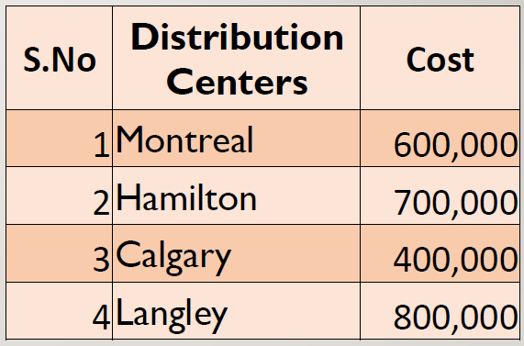

**Average production cost :625000**

*B. Location & Capacity*

The following 5 locations have been identified as potential locations for setting up the plants. We have considered these locations by considering the demand satisfied province wise, reduce the delay in transportation costs, meet the future demands of customers, etc. The following locations are considered for the network model of the supply chain of Tim Hortons.

1. Calgary
2. Langley
3. Debert
4. Montreal
5. Hamilton

The following network model for Tim Hortons distribution centers shows the production and transportations costs for 5 plants listed below. We see that Calgary can satisfy the demand for Alberta & Saskatchewan. Langley is the second distribution center along with Vancouver in British Columbia. While Hamilton will meet the demands for Montreal and Toronto region.

*C. Inventory*

To improve the product availability and reducing costs, we have considered the following points to calculate the total cost of Inventory. The following metrics have been identified that are important for our Tim Hortons.

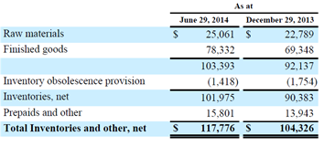

*a) Average Inventory:*The average inventory cost is calculated by considering the Total inventory costs for 6 months period.

Total costs = 117,776 + 104,326/2 = 111051

*b) Components of Inventory:*We have considered the cycle inventory and safety inventory for the Tim Hortons Network model.

1. *Cycle Inventory:* Average amount of inventory used to satisfy demand between supplier shipments

Average Inventory for a week = $3300

1. *Safety Inventory:* Inventory held in case demand exceeds expectations

Safety inventory for a week=$300-$400

*D. Transportation*

The transportation costs for the four potential distribution centers are listed below to supply the required materials to the related restaurant chains pertaining to that region.

Average outbound transportation cost per shipment

total: 1050000

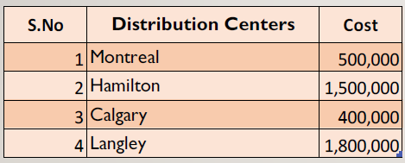

1. *Choice of transportation mode:* Transportation mode would be by truck from supply city to the particular market.

*E. Information*

Information sharing is an important aspect of supply chain. The minimum information should be shared and that should bring the maximum efficiency in the supply chain. The more the information we share, it brings in more complexities, diminishing the profit margin whereas exponentially increasing the other costs. Information gathering is a technique that few supply chain manager’s master. What it requires is to maintain a direct contact between the firm and the customer so that firm knows customer’s needs well and doesn’t lose its important customers. Companies should rely on 80/20 rule in which companies should gather input from 20% of its customers that generate 80% of the income for the company.

1. *Demand planning:* Every company needs to maintain a set inventory and steer its production in a way that it meets its production goals. This is done by forecasting demand. Customer demand planning is a process that helps in forecasting the demand.

Supply chain corrdination helps coordinate various activities in a supply chain process usually managing the inventory and the orders with an aim to improve supply chain performance. Below is discussed supply chain coordination at Tim horton’s while developing nutella based products like nutella pancakes, nutella cookies, nutella croissants etc.

1. *Frequency of update:* Frequency of update is usually monthly or quarterly. At Tim Horton’s it depends on the product launches. Frequency of update increases during festival season or when rewards scheme is launched. Like when Nutella based products were launched, there were frequency of updates at all the stores and franchises on what new products are, how they should be made and how they should be served to the customer.
2. *Forecast error:* It’s the difference between what the real outcome is and what was actually expected or forecasted.

Error = Outcome-forecast.

*F. Sourcing*

Tim Horton’s purchases goods and services from outside or manufactures some of them in-house. Sourcing is essential to determine which goods and services they need to purchase from outside and which they don’t, all of which is done keeping in mind that profitability of supply chain should be maximum.

**Components of Sourcing metric:**

1. *Outsource:* Palm oil, coffee beans, and Dairy products. Coffee beans are outsourced from different vendors to maintain its taste. Company revealed in its annual report last year that it buys coffee beans from countries like Brazil, Guatemala, Colombia, Kenya, El Salvador and other South and Central American countries. Dairy products are bought from Diary Farmers of Canada.
2. *In-house:* Maid stone bakery for bakery products. Maid stone bakery produces Tim Horton’s iconic donuts, Timbits, pastries and some bread too.

**Criterion for selecting suppliers for Tim Horton’s:**

The criterion for selecting suppliers for Tim Horton’s is simple and can be summed up into these few steps:

* All suppliers meet the initial investment requirements and are willing to commit to the Business full time
* Willing to divest of businesses which are direct competition to the Tim Hortons® business
* Prior management experience, preferably in food service and/or restaurant operations
* Strong communication skills and leadership qualities
* Solid business acumen
* Two Partners who will be hands-on operators, willing to commit to the demands of the restaurant full time
* Candidates willing to relocate anywhere within Canada will be prioritized.

1. *Supplier lead time:* Supplier lead time is the time passed between the day an order is booked to the time an actual delivery is made.

Supplier lead time is calculated in days, hours or minutes. There are steps that can be followed to reduce the lead time. These are:

1. Removing unreliable suppliers from the supply chain.
2. Choosing suppliers that are close to the warehouse
3. Sharing demand forecasts with suppliers
4. Bringing external processes in-house
5. Completing multiple processes at the same time.
6. Improving internal communications
7. Communicating more effectively with your customers

**Supplier lead time at Tim Horton’s:**

Order to be booked on TDL page online by Tuesday 14:00 hours. Supply is received by Thursday 12:00 noon. Total time elapsed between the order booked on Tuesday and an order received by Thursday is 46 hours.

1. *Percentage of on time deliveries:* Percentage of on time deliveries in supply chain is how many orders of the customers are processed on time and in full. It means how better we are meeting our customer’s deadlines. If we are too slow that means there are some obstacles in the supply chain or the current processes are not adding any value to the supply chain.

At Tim Horton’s a study conducted revealed that on time delivery window is 5 days early, 0 days late. Tim Horton’s ordered 10 cartons of milk and cream from dairy farmers of Canada and they were received in 3 batches of 3 cartons on 8th November, 3 cartons on 5th December, and 4 cartons on 8th December respectively. The supply window was 5th of December.

Total cartons shipped = 10 cartons

Total cartons delivered on time= 6 cartons

% age of on time deliveries= 6/10= 60%.

*G. Pricing*

Pricing is the last step in a supply chain, and it induces some fresh money in the supply chain. Tim Horton’s has a unique pricing strategy called as everyday value-pricing. This is done by the chain to lower its prices from rivals Starbucks and McDonald’s. The strategy is very simple and that is that the quality of the product is same as its rivals but for a price lower, which enables full customer satisfaction and promotes customer loyalty. The pricing at Tim Horton’s is fixed pricing.

*a) Profit margin:*

Net profit=114,955

Net Sales= 825,353

Profit Margin=114,955/825,353= 0.1392798

1. *Days sales outstanding*

Accounts receivable = 180,102 $

Annual revenue = 825,353$

Days sales outstanding = (180,102/825,353)/365

= 79.64 days

**VIII. DEMAND FORECASTING FOR TIM HORTONS**

The role of forecasting is crucial for Tim Hortons like any other industry as it helps to solve Demand and Supply uncertainty. Forecasting also simplifies the planning decisions for Manufacturers, Distributors and Retailers. Thus, to determine the number of additional bakers, the quantity of products baked, quantity of coffee brewed, to check if the restaurant has reached maximum capacity production, etc. We need to perform demand forecasting to predict the future sales as accurately as possible.

The following forecasting model is based on factors including:

* Previous sales
* Production capacity at store to bake home treats
* Seasonal demands of customers on a daily basis
* Time to replenish products at store
* Quantity of products such as Home treats that are wasted due to excessive production and inaccurate forecasting.

Demand in sales over the past 30 days shows that there is very little variation in the sales of coffee and other products in the store and hence it is advisable to use Time series type of forecast. The daily sales data starting from 2:00 to 24:00 for a store that is open for 24 hours is listed below. The data is split into 12 time periods with a time interval of 2 hours between each period.

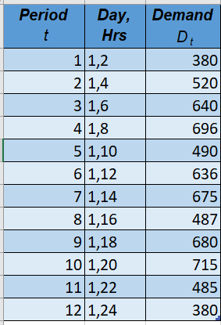

Using the above data, the forecast is predicted using the below equation:

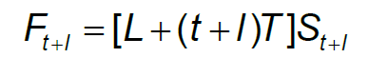

The below function is used for forecasting and it contains the level, demand and seasonal factor.

**Level factor:** From the given data, we can observe a minimum level of 590$ of average sales made on a sunny day.

**Trend factor:** The data is following a trend following a line equation along with its X-variable and Intercept values.

**Seasonal factor:** Sales during hours of 5-7, 11-13 and 18-20 are considerably higher on all days as recorded in a particular store.

The daily demand can be observed as below:

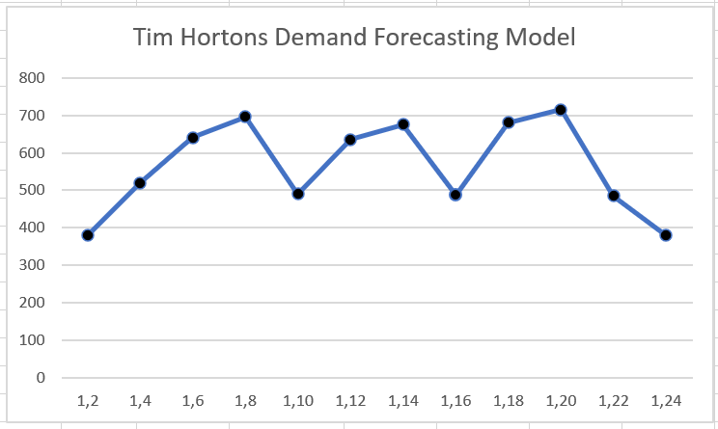

*A. Demand de-seasonalization:*

To de seasonalize the demand, the values of p & t are estimated. As per the above line chart, since the seasonal cycle consists of 4 periods, we take p = 4 & t = 3. Hence the de seasonalized values are calculated as below:

|  |  |  |  |
| --- | --- | --- | --- |
| ***Period***  *t* | ***Day,  Hrs*** | ***Demand***  *Dt* | ***Deseasonalized Demand*** |
| 1 | 1,2 | 380 |  |
| 2 | 1,4 | 520 | 513 |
| 3 | 1,6 | 640 | 619 |
| 4 | 1,8 | 696 | 609 |
| 5 | 1,10 | 490 | 607 |
| 6 | 1,12 | 636 | 600 |
| 7 | 1,14 | 675 | 599 |
| 8 | 1,16 | 487 | 614 |
| 9 | 1,18 | 680 | 627 |
| 10 | 1,20 | 715 | 627 |
| 11 | 1,22 | 485 | 527 |
| 12 | 1,24 | 380 |  |

In the next step, we calculate the Level and Trend values for the given set of X & Y values which are the period and deseasonalized demand values respectively. The Linest function is used to find the X-variable and Intercept values.

FUNCTION: {=LINEST(B12:B19,C12:C19,TRUE,FALSE)}

|  |  |
| --- | --- |
| **X-variable (T)** | **Intercept (L)** |
| 1.747475 | 582.8747475 |

Thus, we have calculated the Deseasonalized demand by utilizing the values as per the below equation: 582.8 + 1.75*(t). The following table lists the Deseasonalized demand values along with the Seasonal factors for all time periods.

|  |  |  |  |
| --- | --- | --- | --- |
| ***Period***  *t* | ***Demand***  *Dt* | ***Deseasonalized Demand*** | ***Seasonal Factor*** |
| 1 | 380 | 584.55 | 0.65 |
| 2 | 520 | 586.3 | 0.89 |
| 3 | 640 | 588.05 | 1.09 |
| 4 | 696 | 589.8 | 1.18 |
| 5 | 490 | 591.55 | 0.83 |
| 6 | 636 | 593.3 | 1.07 |
| 7 | 675 | 595.05 | 1.13 |
| 8 | 487 | 596.8 | 0.82 |
| 9 | 680 | 598.55 | 1.14 |
| 10 | 715 | 600.3 | 1.19 |
| 11 | 485 | 602.05 | 0.81 |
| 12 | 380 | 603.8 | 0.63 |

The actual demand values are deseasonalized and illustrated as below:

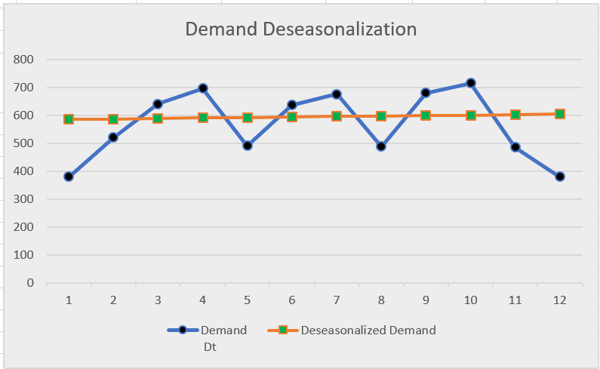

Post deseasonalizing the demand, we estimate the seasonal factors for our model. Since there are 3 seasonal cycles in the trend graph, we consider r=3 & p=3 and calculate the seasonal factors. The forecasted data is calculated based on the below equation. Hence by considering the peak points for the demand curves, we have got 4 estimated seasonal factors and they are listed as below:

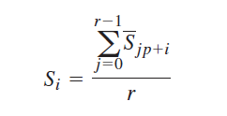

The below figure shows the trend lines graphs for the Actual vs Forecasted data, we notice that the Forecasted data is closed in alignment with the Demand data, this also gives us an indication that the model is forecasting the demand to an acceptable degree of accuracy.

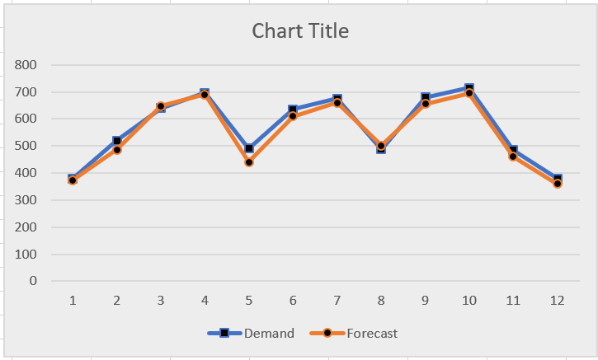

The below figure gives an overview of all calculations required for forecasting the demand on a daily basis. By using the below figures, the restaurant owner will have a chance to reduce the Demand & Supply Uncertainty. Also, they can optimize their resources including logistics costs, shipping costs, ordering costs, etc. Another major advantage of demand forecasting is to reduce the wastage of Home Treats by accurately predicting the required demand and preparing the resources for the same.



Finally, by using the above data, we are now able to predict the future forecasts for the coming days. The below illustrates the demand in sales for the following day for the first 6 hours.

|  |  |  |
| --- | --- | --- |
| **Forecasted Data** | | |
| ***Day,Hrs*** | ***Period*** *t* | ***Forecasted Demand*** |
| 2,0 | 13 | 387 |
| 2,2 | 14 | 510 |
| 2,4 | 15 | 632 |
| 2,6 | 16 | 690 |

Now we record the actual demand*Dt*+1for Period*t****=3*** and compute the error*Et*+1in the forecast for Period *t=3* as the difference between the forecast and the actualdemand. The error for given Period is stated as

**Et+ 1 = Ft+ 1 - Dt+ 1**

In our project, we wanted to implement various adaptive forecasting methods. We choose the forecasting method depending on the characteristic of demand and the composition of the systematic component of demand. In each case, we assume the period under consideration to be *t=3.*

1. *Moving Average Method:*

We initially did not consider the trend and seasonality in our Tim Horton’s data and wanted to forecast our demand. We used 3 period moving average method to determine the forecast. We evaluate level by using the below equation.

**Lt = (Dt + Dt-1 +….. + Dt- N+ 1)/N**

The current forecast for all future periods is the same and is based on the current estimate of level. The forecast is stated as

**Ft+ 1 = Lt and Ft+ n = Lt**

We have calculated the forecast values for period 2,1 and 2,2 using simple exponential smoothing with alpha=0.1. Below table gives the level and forecasted values for the future.

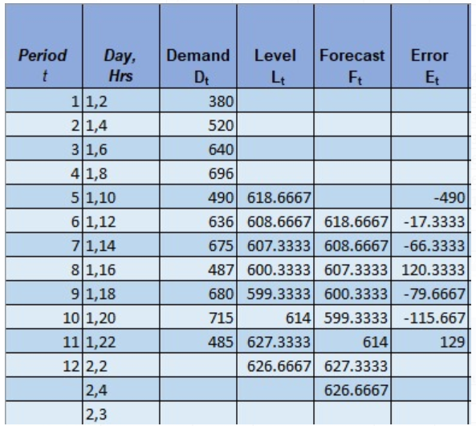

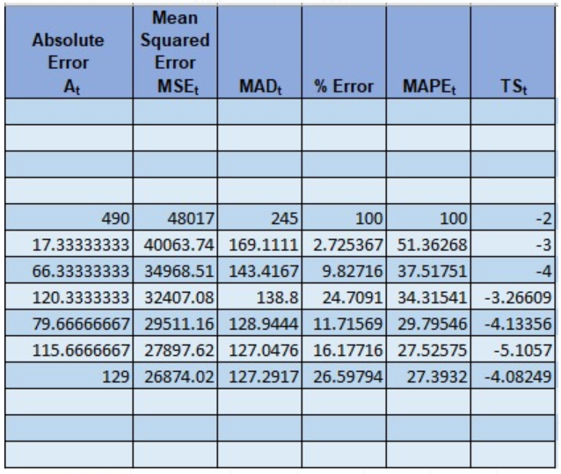

1. *Simple Exponential Smoothing:*

In this method also, there is no trend and observability. The systematic component of demand is equal to the level. The below are the calculated forecast and error estimates of the Simple Exponential Smoothing.

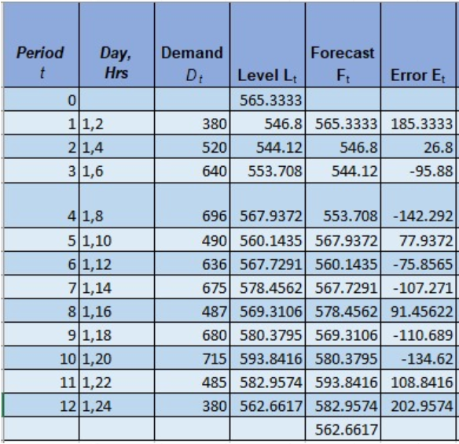

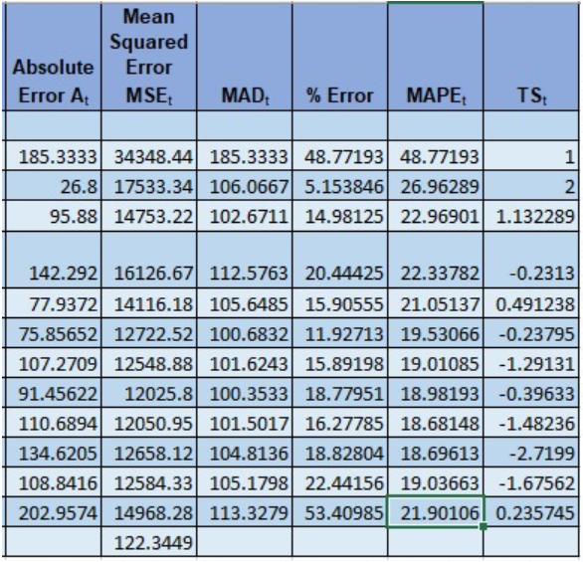

1. *TREND-CORRECTED EXPONENTIAL SMOOTHING (HOLT’S MODEL)*

The trend-correctedexponential smoothing (Holt’s model) method is appropriate when demand is assumed to have a level and a trend in the systematic component but no seasonality. In this case, we have systematic component of demand is equal to the sum of level and trend. We calculate the Level and Trend values for the given set of X & Y values which are the period and demand values respectively. The Linest function is used to find the X-variable and Intercept values.

FUNCTION = LINEST(AC25:AC36,AB25:AB36)



Below are the forecasted and estimate error values using Holt’s model with a = 0.01 and b = 0.02.

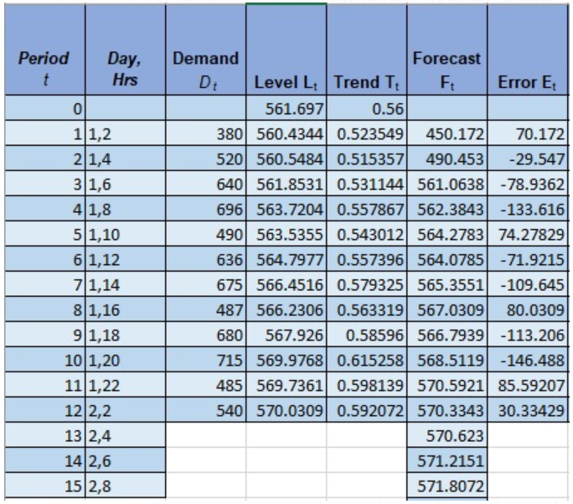

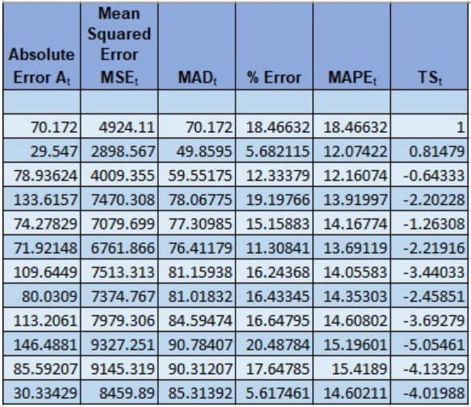

1. *Trend- and seasonality-corrected exponential smoothing (winter’s model):*

We considered the level, trend and a seasonal factor to use the Winter’s model. We calculate the Level and Trend values for the given set of X & Y values which are the period and demand values respectively. The Linest function is used to find the X-variable and Intercept values.

FUNCTION = LINEST(B17:B28,A17:A28)



We obtain the initial estimates of level, trend, and seasonal factors exactly by de-seasonalizing the demands. Then we calculate the revised estimate of level, trend and seasonal factor with a = 0.45, b = 0.2 and g = 0.35 using below equations.

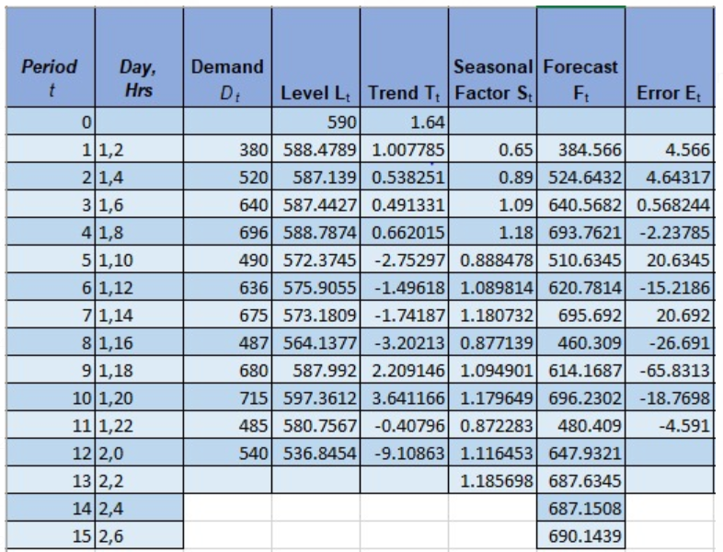

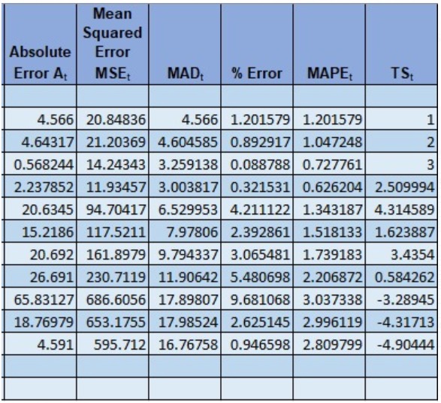

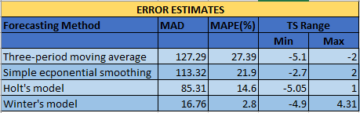

***IX. MANAGING ECONOMIES OF SCALE AT TIM HORTONS***

Considering the Inventory profile of Tim Hortons, the lots are ordered every week for all the required quantities of Home treat items. Analyzing the Cycle Inventory and Average flow time for these Home treats gives us the below numbers:

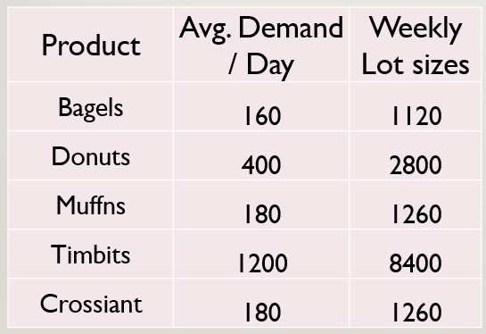

The below figure shows the Inventory profile for a Tim Hortons store explaining the Inventory plotted on Y-axis and Time plotted on X-axis. We see that the replenishment cycle is 7 days for this store.

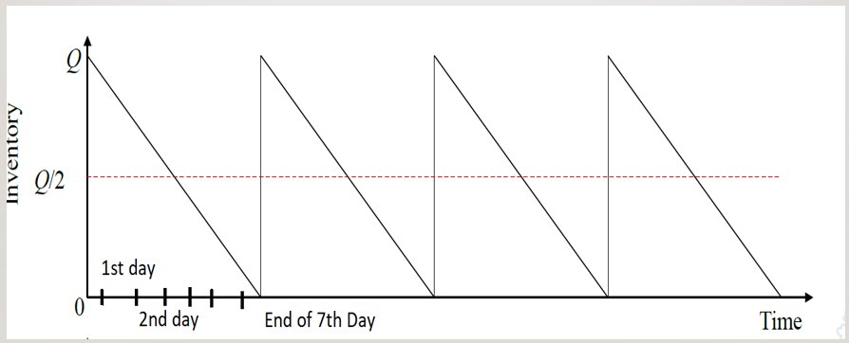

In contrast to the Individual orders, it is advisable and cost effective to use Joint order policy to place the order. This is mainly done to reduce the fixed order costs such as Common Order cost. However, keeping in mind the Inventory costs the Lot size are ordered weekly.

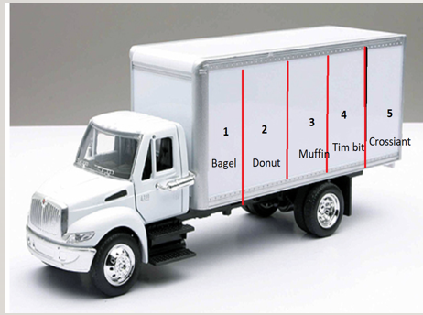

* 1. *Individual Orders Calculations:*

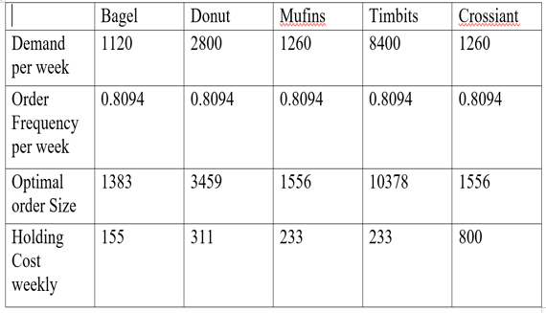

* 1. *Joint Orders Calculations:*

Common Order Cost(S) = $1000

Product specific cost = $100

Total Order Cost = $1000+5*($100) = $1500

Holding cost(h)=0.3

Material Costs for all products:

Bagel = $0.75

Donuts = $0.60

Muffins = $1

Tim bits = $0.15

Croissant = $1.20

After calculation we got order frequency (n) = 0.8094

Q(bagel) = Demand(bagel)/order frequency =1120/0.8094 = 1383

Q (Donut) = 2800/0.8094 = 3459

Q(Muffins) = 1260/0.8094=1556

Q(Tim bits) = 8400/0.8094 = 10378

Q(Croissant) = 1260/0.8094 = 1556

Weekly order Cost= n*S = 0.8094*1500 = $1214

**Total Weekly Cost = $2946**

**X. CONCLUSION**

Therefore, through this project we have realized the importance of Demand Forecasting to any Supply Chain. Forecasting need not necessarily be accurate, however by analyzing and applying the different techniques one can choose the best forecasting model that can be applied to their Company and Supply Chain model.

Consequently, we have been able to estimate the next day demands in the Tim Hortons store. Therefore, we are in a better position to prepare ourselves for the demand. This has resulted in Baking the required quantity of Home Treat products as per the need and hence Reduce the Wastage of Baked Home treats.

REFERENCES

1. <http://sustainabilityreport.timhortons.com/planet-supply-chain.html>
2. <https://business.financialpost.com/news/retail-marketing/tim-hortons-to-upgrade-distribution-system-and-open-new-warehouses>
3. <https://majorprojects.alberta.ca/details/Tim-Hortons-Distribution-Centre/3740>
4. <https://www.timhortons.com/ca/en/corporate/news-release.php?id=11063>
5. TH_Investor_Conference_Report